# OpenTherm interface board

I want to create a new version of my room thermostat, and this time I want to order an assembled PCBA at JLCPCB. Eventually I also want to add a USB-C connector, power supply and ESP32 to the board, but to try out if my KiCad skills are sufficient, I first created a very simple board, which only consists of the redlined area of the schematic below:

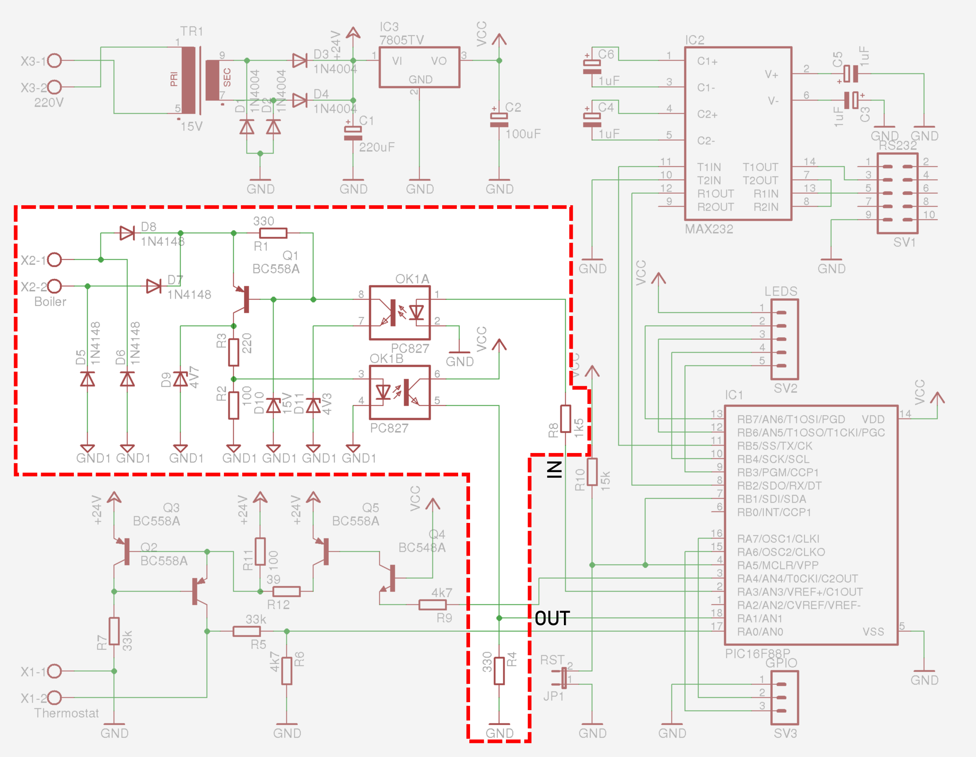

I copied this schematic from: [otgw.tclcode.com/schematic](https://otgw.tclcode.com/schematic.html#schematic)

I needed to transfer the components list:

* Conrad numbers are provided, where I need JLCPCB part numbers
* I need to substitute through-hole components by surface mounted devices

The original parts list is (only the relevant parts):

| **Reference** | **Description** | **Value** | **Conrad** | **Detailed description from Conrad** (Dutch) |
| --- | --- | --- | --- | --- |
| **OK1** | Dual opto-coupler | PC827 | [140235-89](https://www.conrad.nl/zoeken?search=140235-89) | Broadcom Optocoupler fototransistor ACPL-827-000E DIP-8 Transistor DC |
| **Q1** | PNP Transistor | BC558A | [1262971-89](https://www.conrad.nl/zoeken?search=1262971-89) | Diotec Transistor (BJT) - discreet BC558A TO-92 PNP |
| **D5**, **D6**, **D7**, **D8** | Diode | 1N4148 | [162280-89](https://www.conrad.nl/zoeken?search=162280-89) | Diotec Ultrasnelle Si-diode 1N4148 SOD-27 75 V 150 mA |
| **D9** | Zener Diode | 4V7 | [180084-89](https://www.conrad.nl/zoeken?search=180084-89) | Diotec Zenerdiode ZPD4.7 Behuizingssoort (halfgeleider) DO-35 Zenerspanning 4.7 V Vermogen (max.) P(TOT) 506 mW |
| **D10** | Zener Diode | 15V | [180203-89](https://www.conrad.nl/zoeken?search=180203-89) | Diotec Zenerdiode ZPD15 Behuizingssoort (halfgeleider) DO-35 Zenerspanning 15 V Vermogen (max.) P(TOT) 518 mW |
| **D11** | Zener Diode | 4V3 | [180076-89](https://www.conrad.nl/zoeken?search=180076-89) | Diotec Zenerdiode ZPD4.3 Behuizingssoort (halfgeleider) DO-35 Zenerspanning 4.3 V Vermogen (max.) P(TOT) 505 mW |
| **R2** | 1/4 Watt 5% Resistor | 100 | [1417639-89](https://www.conrad.nl/zoeken?search=1417639-89) | Yageo CFR25J100RH CFR-25JT-52-100R Koolfilmweerstand 100 Ω Axiaal bedraad 0207 0.25 W 5 % 1 stuk(s) |
| **R3** | 1/4 Watt 5% Resistor | 220 | [1417693-89](https://www.conrad.nl/zoeken?search=1417693-89) | Yageo CFR25J220RH CFR-25JT-52-220R Koolfilmweerstand 220 Ω Axiaal bedraad 0207 0.25 W 5 % 1 stuk(s) |
| **R1**, **R4** | 1/4 Watt 5% Resistor | 330 | [1417730-89](https://www.conrad.nl/zoeken?search=1417730-89) | Yageo CFR25J330RH CFR-25JT-52-330R Koolfilmweerstand 330 Ω Axiaal bedraad 0207 0.25 W 5 % 1 stuk(s) |
| **R8** | 1/4 Watt 5% Resistor | 1k2 | [1417712-89](https://www.conrad.nl/zoeken?search=1417712-89) | Yageo CFR25J1K2H CFR-25JT-52-1K2 Koolfilmweerstand 1.2 kΩ Axiaal bedraad 0207 0.25 W 5 % 1 stuk(s) |

# Modified schematic

My modified schematic looks like this:

# Finding equivalent SMD components

I installed a library of JLCPCB components and footprints from <https://github.com/CDFER/JLCPCB-Kicad-Library.git>, but found that many components that are available at JLCPCB are missing. I tried to find equivalent SMT components on [https://jlcpcb.com/partdetail](https://jlcpcb.com/partdetail/). Typically, several versions of a component exist, and specifications are slightly different from the original through-hole part.

Starting with D1, D2, D3 and D4 in the new bill of materials, this is the original 1N4448 from the Conrad part:

In JLCPCB, I sorted on available stock and started at the top:

Here is a sample of the datasheet of the Xzt 1N4448W, LCSC# C5805633:

Comparison:

| **Property** |  | **1N4448**  **Conrad** | **1N4448W**  **JLCPCB** | **Suitable** |
| --- | --- | --- | --- | --- |
| Reverse voltage | VR | 75 V | 100 V (?) | OK |
| Repetitive peak reverse voltage | VRRM | 100 V | 75 V | NOK |
| Max. average forward rectified current, R-load | IFAV | 150 mA | ? | ? |
| Repetitive peak forward current | IFRM | 500 mA | ? |  |
| Non-repetitive peak forward current, tp = 1 µs | IFSM | 2000 mA | 2 A | OK |
| Power dissipation | Ptot | 500 mW | 500 mW | OK |

To know if the JLCPCB version is suitable for this application, I would need to reverse-engineer the circuit based on the OpenTherm specification. **What kind of due diligence is common when designating alternative components?**

# Reverse engineering the schematic

To determine the requirements of all components, I decided to simulate the schematic in KiCAD.

First, I retrieved [the specification of the OpenTherm protocol](http://files.domoticaforum.eu/uploads/Manuals/Opentherm/Opentherm%20Protocol%20v2-2.pdf):

The units are Volts horizontally and mA vertically. The boiler can send signals to the controller by changing the current, the controller sends signals back to the boiler by changing the voltage.

Fun fact: it is backwards compatible with old-style hydrogen-drop-in-glass-bead Honeywell thermostats, since if the circuit is closed or open for longer periods of time, the boiler starts or stops boiling at full load.

Without external load, the voltage emitted by the boiler is 42 V.

I calculated 4 cases:

|  |  |  |
| --- | --- | --- |
| **Case** | **Current controlled by boiler** | **State of optocoupler U1** |
| 1 | 7 mA | Open |
| 2 | 23 mA | Open |
| 3 | 7 mA | Closed |
| 4 | 23 mA | Closed |

I learned that it is important to start with really simple simulations to understand if the simulation works well, and then make schematics more complicated.

The first circuit involved a voltage source, a resistor and a diode. I retrieved the VDC source and the diode from the simulation_SPICE library. In other libraries, the pinout of the diode is often swapped.

In the spice simulator, a sweep analysis is chosen, sweeping the voltage of BT1 between -5 and +5 V with steps of 0.01V:

The voltage of the output changes as function of the supplied voltage:

When the supplied voltage is negative, the diode conducts current, and there is only a -0.7V potential at the output. When the supplied voltage is positive, the diode blocks and the output voltage becomes equal to the supply voltage.

Now, we will see if a Zener diode works well. Replace the diode with a Zener:

The Zener is not available in the simulation_SPICE library, so I used D_zener from the Device library. In this library, the pins are swapped, so Sim.Pins has to be modified to 1=K 2=A. Pin numbers can be shown in the schematic by flagging the “Show pin numbers”in the Symbol Properties.

Set the parameters of the Zener diode as follows, specifying the breakdown voltage bv=3 V, and defining pin 1 as Anode and pin 2 as Kathode:

The simulation shows:

|  |  |  |
| --- | --- | --- |
| -5 … | -1.4 V | Zener conducts, resulting in a potential of -0.7 V at the output |
| -0.5 … | +2.8 V | Output is proportional to input |
| +3 … | +5 V | Zener clips output to 3 V |

We can also show the current through the Zener diode:

In KiCAD, a positive voltage leads to a current in the negative direction. Thus, when the potential is ‑5 V, the current through the circuit is positive. Between -0.7 V and +3 V, the current remains constant, where the resistance of the Zener remains very low. Beyond +3 V, the conductivity of the Zener increases to keep voltage b constant at +3 V.

ChatGPT suggested to use the MMBT2907A as an SMT alternative for the BC558, and kindly suggested the following pspice parameters for the Gummel-Poon model:

|  |  |  |  |
| --- | --- | --- | --- |
| Saturation Current | IS | 6.734×10-14 | A |
| Forward Beta or Current Gain | BF | 220 | - |
| Forward Emission Coefficient | NF | 1 | - |
| Forward Early Voltage | VAF | 60 | V |
| Corner for Forward Beta Roll-Off | IKF | 0.1 | A |
| Reverse Beta | BR | 8 | - |
| Reverse Emission Coefficient | NR | 1 | - |
| Reverse Early Voltage | VAR | 8 | V |
| Corner for Reverse Beta Roll-Off | IKR | 0.03 | A |
| Base-Collector Leakage Saturation Current | ISC | 1x10-13 | A |
| Base-Collector Leakage Emission Coefficient | NC | 2 | - |
| Base-Emitter Zero-Bias Capacitance | CJE | 24p | F |
| Base-Emitter Built-In Potential | VJE | 0.75 | V |
| Base-Emitter Capacitance Grading Coefficient | MJE | 0.33 | - |
| Forward Transit Time | TF | 200p | s |
| Coefficient for Excess Phase in Forward Transistor Region | XTF | 2 | - |
| Voltage for Coefficient XTF | VTF | 2 | V |
| High Current Injection for Transit Time Modulation | ITF | 0.02 | A |
| Excess Phase Related to TF | PTF | 0 | - |
| Base-Collector Zero-Bias Capacitance | CJC | 12p | F |
| Base-Collector Built-In Potential | VJC | 0.5 | V |
| Base-Collector Capacitance Grading Coefficient | MJC | 0.5 | - |
| Fraction of Base-Collector Capacitance | XCJC | 0.5 | - |
| Reverse Transit Time | TR | 200n | s |
| Base-Substrate Zero-Bias Capacitance | CJS | 0 | F |
| Base-Substrate Built-In Potential | VJS | 0.75 | V |
| Base-Substrate Capacitance Grading Coefficient | MJS | 0.5 | - |
| Zero-Bias Base Resistance | RB | 10 | Ω |
| Emitter Resistance | RE | 0.3 | Ω |
| Collector Resistance | RC | 0.3 | Ω |

To check if the transistor works, I added a voltage supply and changed the existing supply to a current source:

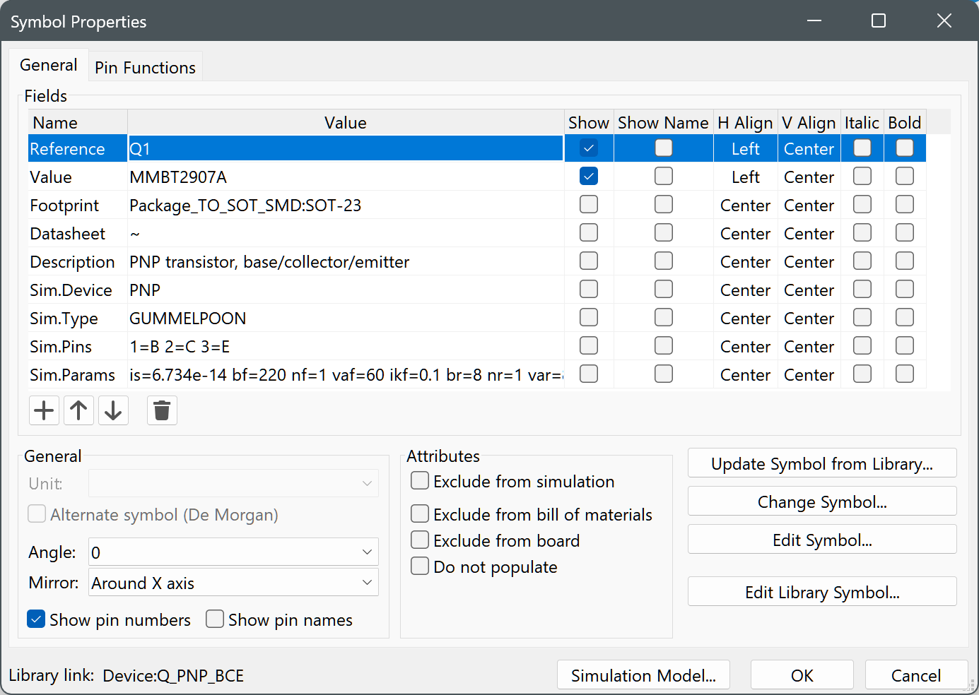

is=6.734e-14 bf=220 nf=1 vaf=60 ikf=0.1 br=8 nr=1 var=8 ikr=0.03 isc=1e-13 nc=2 rb=10 re=0.3 rc=0.3 cje=24p vje=0.75 mje=0.33 tf=200p xtf=2 vtf=2 itf=0.02 ptf=0 cjc=12p vjc=0.5 mjc=0.5 xcjc=0.5 tr=200n cjs=0 vjs=0.75 mjs=0.5

(for BC558 this is:

is=1.4e-14 bf=300 nf=1 vaf=50 ikf=0.03 br=6 nr=1 var=10 ikr=0.03 isc=1e-13 nc=2 rb=2 re=0.5 rc=1 cje=20p vje=0.63 mje=0.33 tf=0.4n xtf=2 vtf=5 itf=0.3 ptf=0 cjc=7.5p vjc=0.75 mjc=0.33 xcjc=0.5 tr=0.1n cjs=0 vjs=0.75 mjs=0.5)

This time, I swept the current of I1 while keeping V1 steady at 5V. The collector of the transistor can drive 100mA, so the resistor was chosen to be 5V/0.1A=50Ω. The current gain of the transistor is 220, so to have the transistor drive 100 mA, the base current must be 50m/220=450µA.

The simulation shows that the transistor remains closed below 0A, and opens between 0 and 450µA:

Now all components have been tested individually, the core of the OpenTherm circuit can be simulated to investigate if it is working as expected:

When U1 is closed, it will be modelled as a simple diode. When U1 is open, both U1 and D7 are omitted from the schematic. By driving the input with different currents, 4 situations can be simulated:

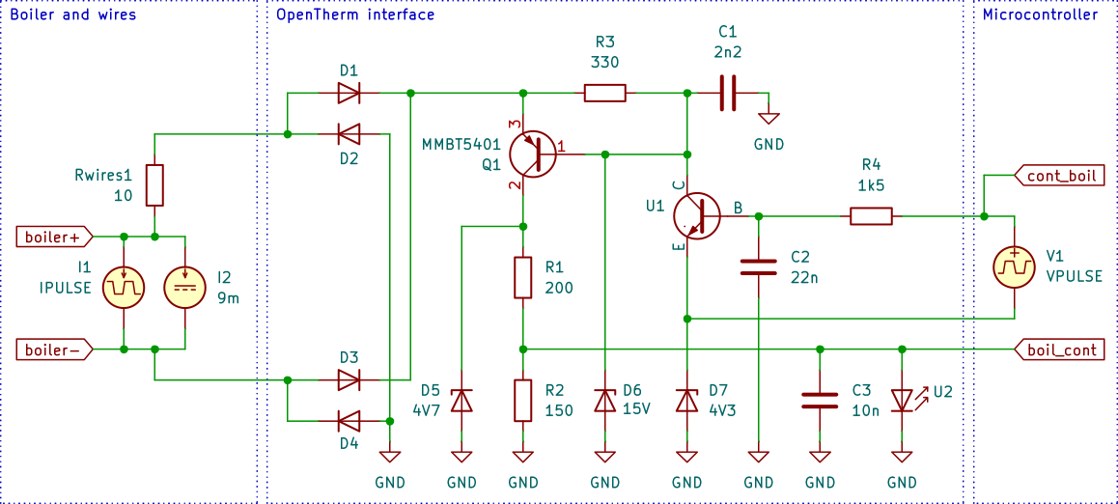

The components in the left rectangle mimic the boiler. The boiler provides a current on the wires of the OpenTherm bus, with a minimum current of 9 mA and a maximum current of 23 mA with a period of 1ms. The rise and fall times are specified as less than 50µs in the OpenTherm specification.

The interface is in the centre rectangle. The BC558A is replaced by a very common SMD version, the MMBT5401. The original optocouplers U1 and U2 (EL357N-G) were replaced by dummies for the simulation (a PNP transistor and an LED respectively), since a SPICE model of the EL357N-G was not available. Resistor R2 was increased from 100 Ω to 150 Ω to more clearly separate the vboil_cont signal from the forward voltage of the LED of the EL357N-G. Three small capacitors were added to reduce ripple on the signals.

The right rectangle represents the microcontroller. V1 provides a 1ms pulse which is delayed by 125 µs, so it is a quarter phase behind the current signal from the boiler. In reality, the boiler responds after a request from the controller is completed, so either current or the voltage are modulated.

The results of the simulation are:

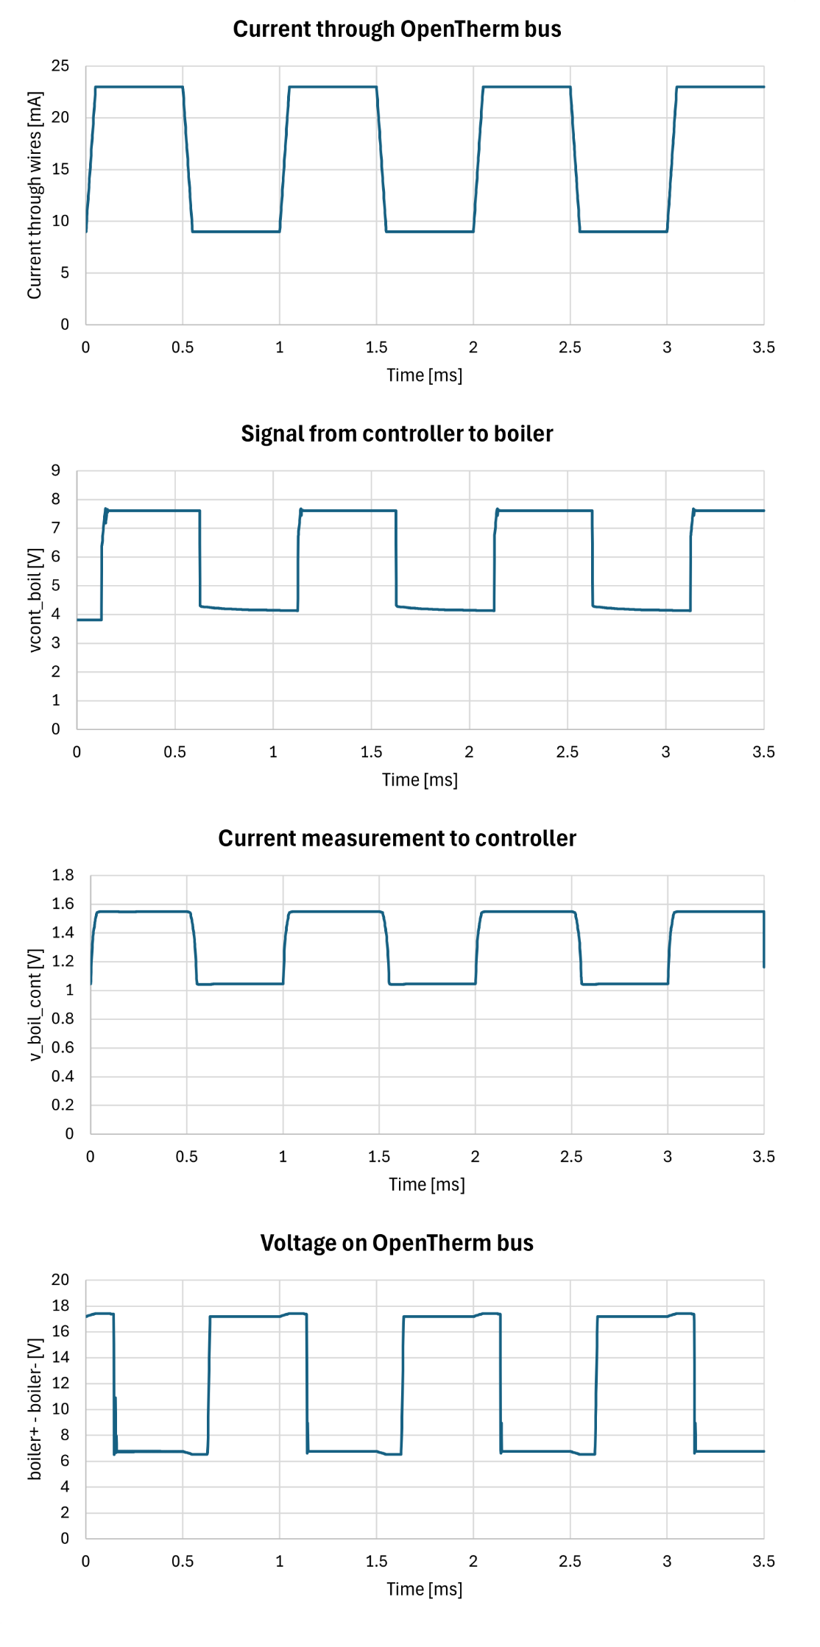

Conclusions:

1. Changes in the current signal modulated by the boiler do not interfere with the voltage signal modulated by the controller, or vice versa.
2. The 9…23 mA signal from the boiler translates into a 1.05…1.56 V signal for the LED of optocoupler U2. The LED of the EL357N-G has a forward voltage of typically 1.2 V and max. 1.4 V. The signal values are well outside of this range.
3. The output of the controller results in a voltage on the OpenTherm bus of 6.8 V or 17.4 V. This is outside the specified 7…15 V range of the OpenTherm specification.
4. The circuit performs according to the OpenTherm specification

# Specifications for components

Specifications for the components were derived from the simulations.

## Diodes D1…D4

Without margin, these diodes should be able to dissipate 20 mW and draw 25 mA of current.

|  |  |  |  |  |  |  |
| --- | --- | --- | --- | --- | --- | --- |
|  | |  | | | | |
| **Property** | | **Symbol** | | **Unit** | **Required** | **1N4148WS** |
| Non-Repetitive Peak Reverse Voltage | | VRM | | V | 42 | 100 |
| Average Rectified Output Current | | IO | | A | 25m | 150m |
| Power Dissipation | | PD | | W | 20 | 200m |
|  | |  | |  |  |  |
| Package | |  | |  |  | SOD-323 |
| JLCPCB | |  | |  |  | C2128 |

## Zener D5, 4V7

|  |  |
| --- | --- |
|  |  |

|  |  |  |  |  |  |
| --- | --- | --- | --- | --- | --- |
| **Property** | **Symbol** | **Unit** | **Required** | **BZT52C4V7S** | **BZX84C4V7** |
| Zener voltage | Vz | V | 4.7 | 4.7 | 4.7 |
| Power dissipated | PD | W | 24m | 200m | 350m |
| Zener current | Iz | A | 4.8m | Ok | ok |
| Package |  |  |  | SOD-323 | SOT-23 |
| JLCPCB |  |  |  | C5190168 | C2926229 |
| Stock |  |  |  | 18723 | 22953 |

## Zener D6, 15

|  |  |  |  |  |  |  |  |
| --- | --- | --- | --- | --- | --- | --- | --- |
|  | | | |  | | | |
| **Property** | **Symbol** | **Unit** | **Required** | | **BZT52C15V** | **BZT52C15S** |
| Zener voltage | Vz | V | 15 | | 13.8…15.6 | 13.8…15.6 |
| Power dissipated | PD | W | 35m | | 500m | 200m |
| Zener current | Iz | A | 2.5mA | | ok | Ok |
| Package |  |  |  | | SOD-123 | SOD-123 |
| JLCPCB |  |  |  | | C5299435 | C19077448 |
| Stock |  |  |  | | 6263 | 10668 |

## Zener D7, 4V3

|  |  |  |  |  |  |  |  |
| --- | --- | --- | --- | --- | --- | --- | --- |
|  | | | |  | | | |
| **Property** | **Symbol** | **Unit** | **Required** | | **BZT52C4V3** |  |
| Zener voltage | Vz | V | 4.3 | | 4.3 |  |
| Power dissipated | PD | W | 35m | | 500m |  |
| Peak power |  | W | 160m | |  |  |
| Zener current | Iz | A | 3m | | ok |  |
| Package |  |  |  | | SOD-123 |  |
| JLCPCB |  |  |  | | C726993 |  |
| Stock |  |  |  | | 11300 |  |

## Transistor Q1, BC558A

|  |  |
| --- | --- |
|  |  |
|  |  |

|  |  |  |  |  |  |  |
| --- | --- | --- | --- | --- | --- | --- |
| **Property** | **Sym** | **Unit** | **Required** | **BC856A-7-F** | **MMBT2907A** | **PMBT3906,215** |
| Emitter collector voltage | VCEO | V | 15 | 65 | 60 | 40 |
| Collector current | IC | A | 40m | 100m | 600m | 200m |
| Base current | IB | A | 15m | 200m |  | 100m |
| Power dissipation | PD | W | 250m | 310m | 300m | 250m |
|  |  |  |  |  |  |  |
| Package |  |  |  | SOT-23 | SOT-23 | SOT-23 |
| JLCPCB |  |  |  | C460180 | C916373 | C8670 |
| Stock |  |  |  | 17393 | 173550 | 108572 |

## U1 Optocoupler EL357N(A)(TA)-G

|  |  |
| --- | --- |
|  |  |

|  |  |  |  |  |
| --- | --- | --- | --- | --- |
| **Property** | **Symbol** | **Unit** | **Required** | **EL357N(C)(TA)-G** |
| Current | I | A | 3m |  |
| Power | P | W | 3m |  |
|  |  |  |  |  |
|  |  |  |  |  |
|  |  |  |  |  |
| Package |  |  |  | SOP-4-2.54mm |
| JLCPCB |  |  |  | C29981 |
| Stock |  |  |  | 667116 |

## Resistors R1…R4

|  |  |  |  |  |  |
| --- | --- | --- | --- | --- | --- |
|  |  | **R1** | **R2** | **R3, R5** | **R4** |
| Resistance | Ω | 200 | 150 | 330 | 1k5 |
| Power | W | 125m | 125m | 125m | 125m |
| Type |  | 0805W8J0201T5E | 0805W8F1500T5E | 0805W8F3300T5E | 0805W8F1501T5E |
| Package |  | 0805 | 0805 | 0805 | 0805 |
| JLCPCB |  | C17540 | C17471 | C17630 | C4310 |

## Capacitors

|  |  |  |  |
| --- | --- | --- | --- |
|  |  | **C1, C3** | **C2, C4** |
| Capacitance | F | 10n | 2n2 |
| Rated voltage | V | 50 | 50 |
| Type |  | 0603B103K500NT | 0603B222K500NT |
| Package |  | 0603 | 0603 |
| JLCPCB |  | C57112 | C1604 |